Narrow horizontal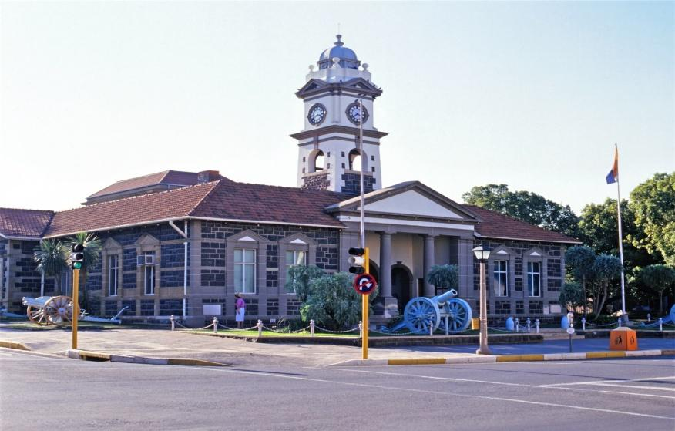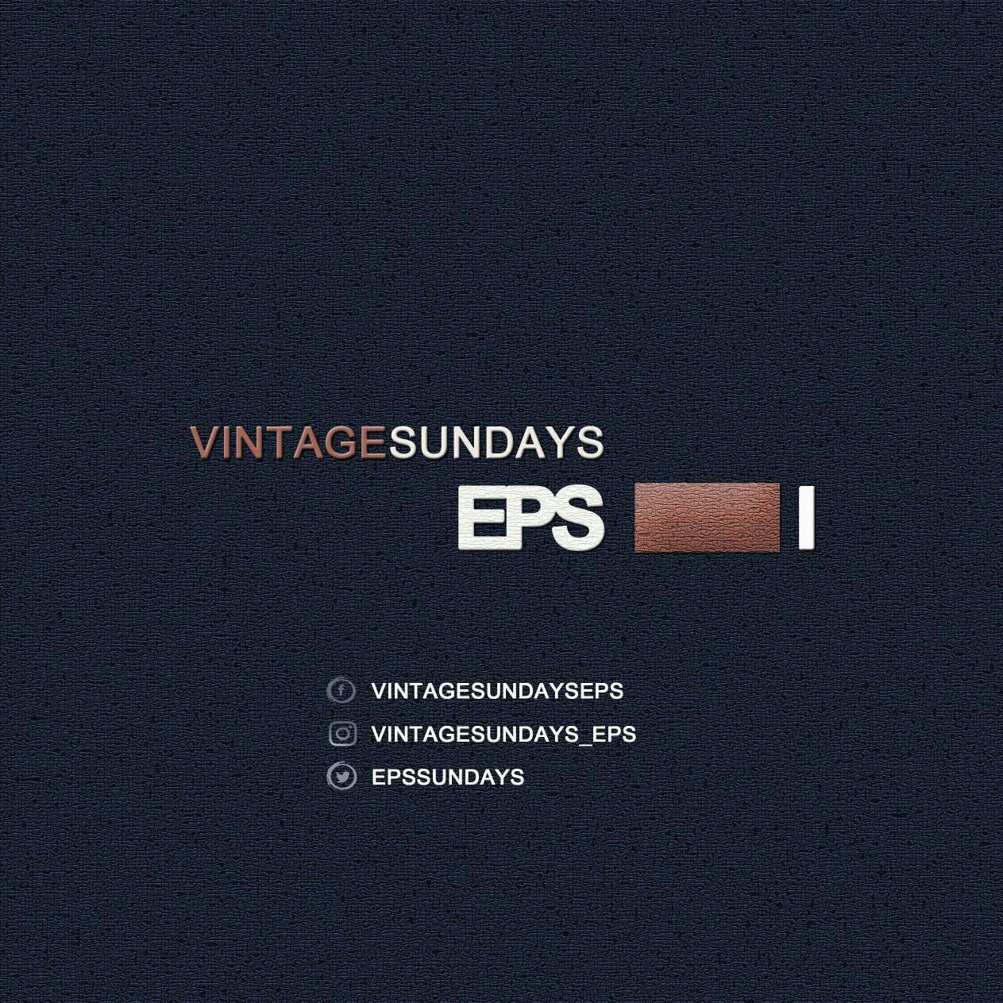

Table of contents

1. Introduction

1.1 Company Profile and details

1.2 Event Introduction

1. Executive summary
2. The need /current problem
3. Solution
4. Community benefits and support
5. Upcoming Event and Proposal
6. Event Portfolio



VINTAGE SUNDAYS EPS

[17 Adam Tas Road]

Event Busines Proposal

Travel & Tourism Kzn Region

**BACKGROUND**

**VINTAGE SUNDAYS EPS**

We aim to Unite and inspire Young and Old generations from Local to International audience in **Travel & Tourism** Market, by influencing and implementing **Vintage & Classic** matured experience Events that has relevant overflowing Activities concepts. We target both formal & informal economy in the following sectors:

* Arts & Humanities e.g. relevant Vintage & Classic activities
* Fashion
* Food
* Entertainment
* Social events
* Business Stalls
* Lifestyle and
* Everything that compliments Ladysmith, in the Uthukela District, as a Vintage Town

As a small developing Arts Humanities & Travel Tourism Company we made Our research especially around our local municipality, Alfred Duma Town and we realized the huge market gap in ***Vintage*** Concepts that can definitely strength our economic growth and development through Travel and Tourism, and in collaboration with Arts and Humanities.

***Vintage Sundays Eps*** is the first and only Event found & discovered in Ladysmith that was launched in 2019. The research findings indicated that the Ladysmith town has a rich value of history and records honored by the whole wide world with current high rating of Artists, Skills and Possibilities that can benefit, attract and increase our tourism market and interests, for example

Vintage Sundays Eps supports and uplifts 90% of local Talent and Arts Skills from previous three (3) hosted events already and with plan of making sure we give all local talent and skills an opportunity and platform, especially where youth is concerned.